Roboflow

[ROBOFLOW](https://roboflow.com/)

<https://roboflow.com/#WatchDemo>

<https://docs.roboflow.com/>

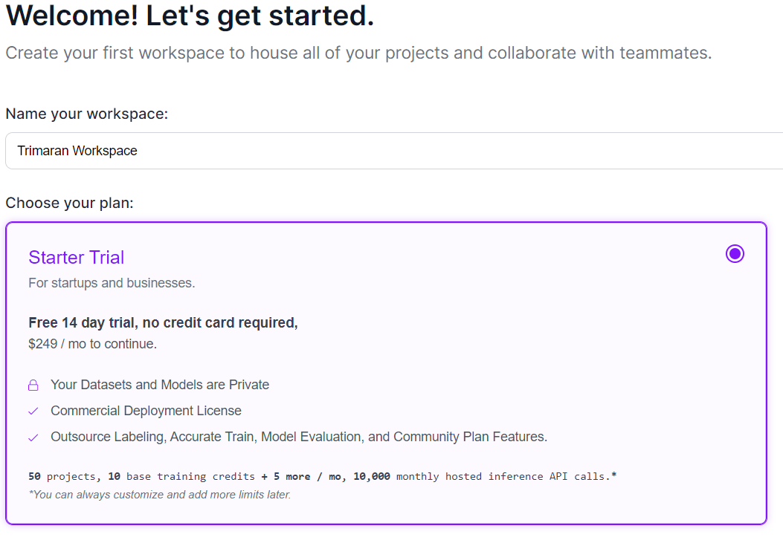

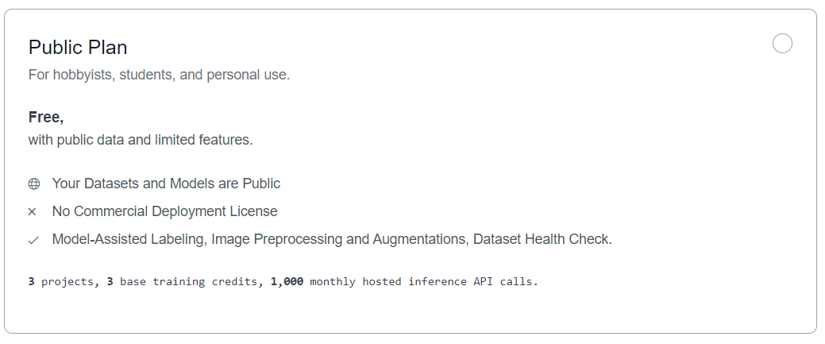

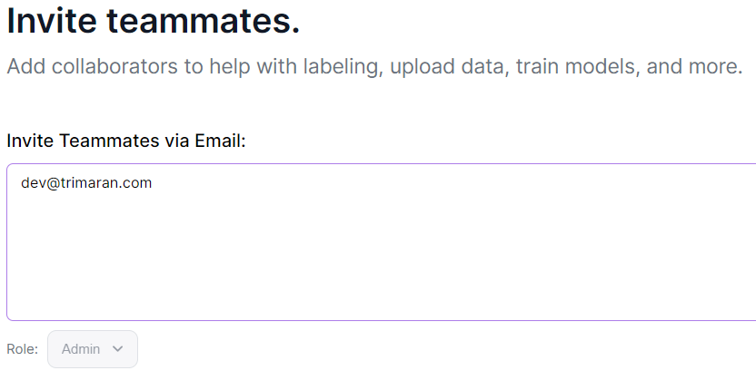



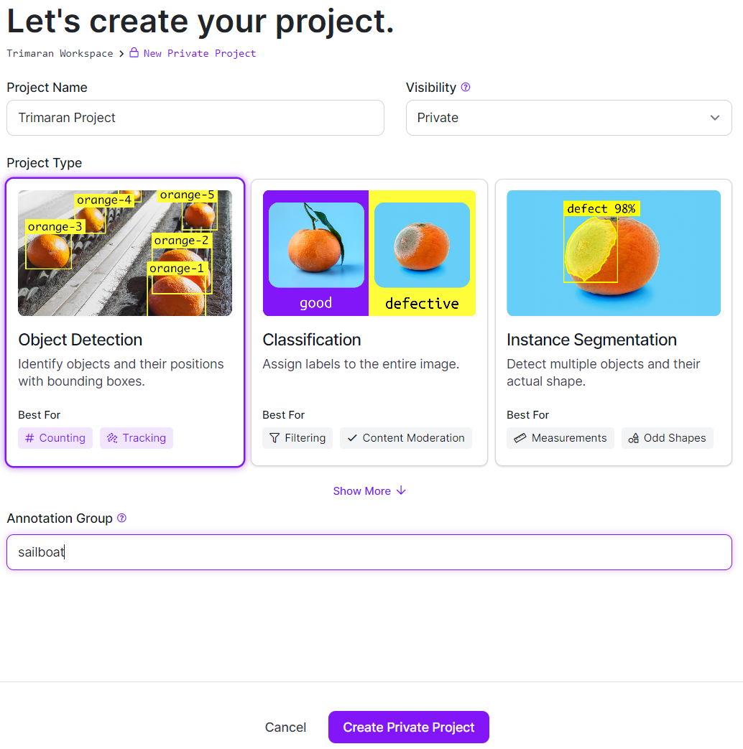

***Object Detection***: Find the location of objects in an image.  
***Single-Label Classification***: Given a limited set of categories, assign a label to an image.  
***Multi-Label Classification***: Given a limited set of categories, assign an arbitrary number of labels that are relevant to the image.  
***Instance Segmentation***: To the pixel level, find the location of objects in an image.  
***Semantic Segmentation***: To the pixel level, find the location of objects in an image and create unique references for each object found.  
***Keypoint Detection***: Find the location of objects and their keypoints in an image. Commonly used for determining the pose of an object.

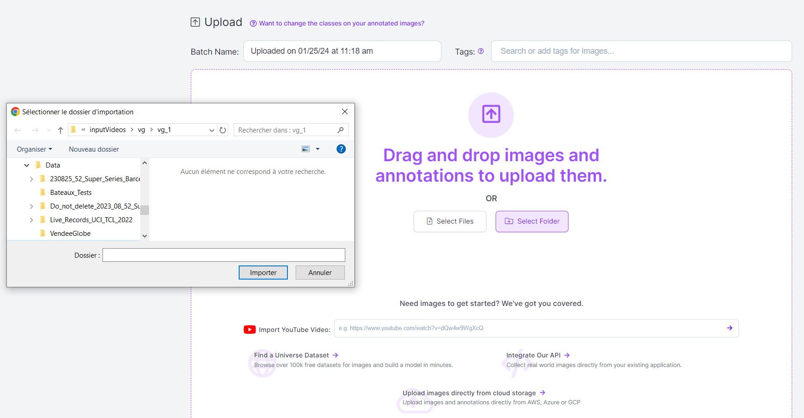

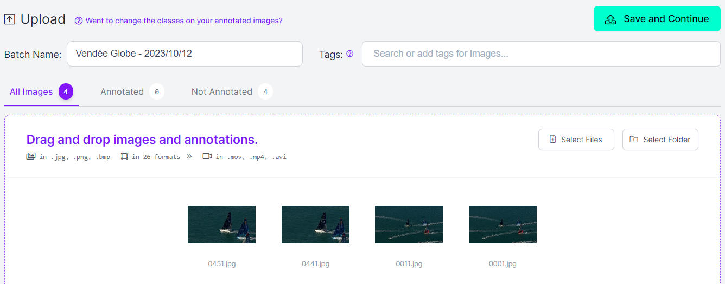

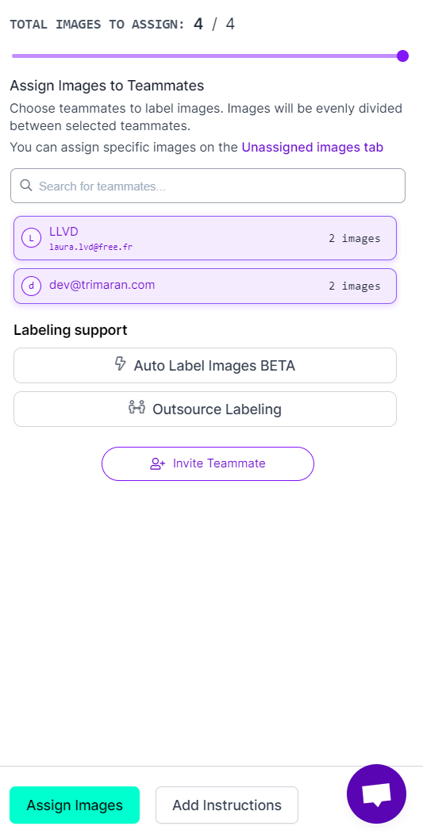

Annotation : rectangle bounding box

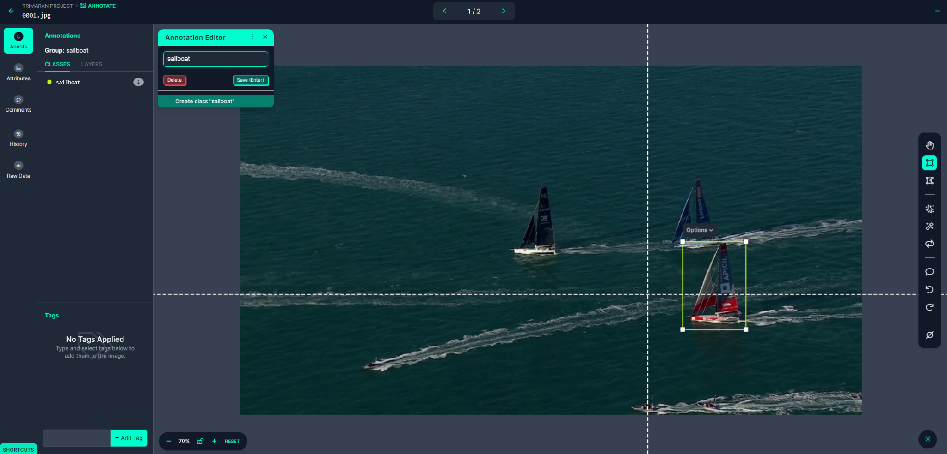

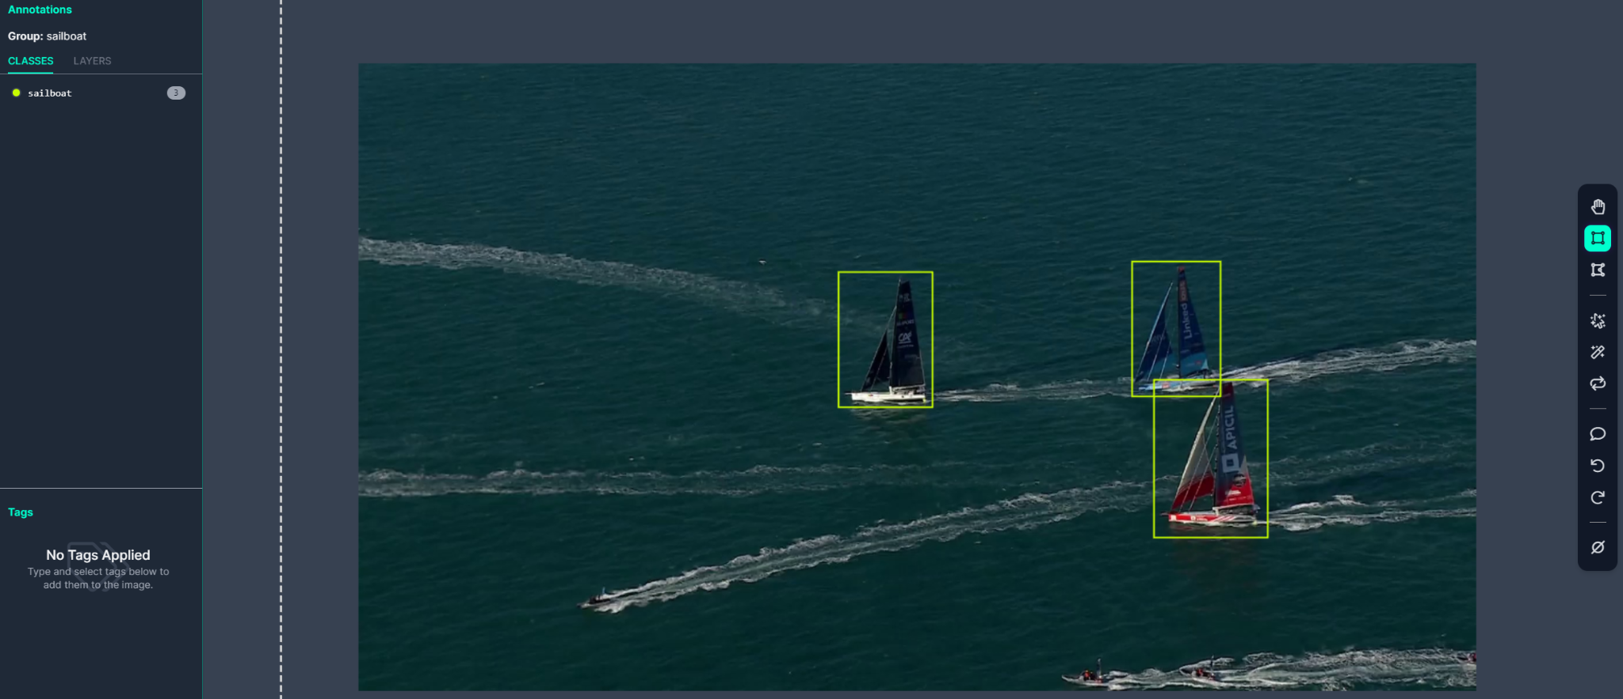

Annotation : segmentation with smart polygone

Left click outside the green zone : expand the zone to this point and to similar pixels around

Left click inside the green zone : limits the zone to get out this point and similar pixels around

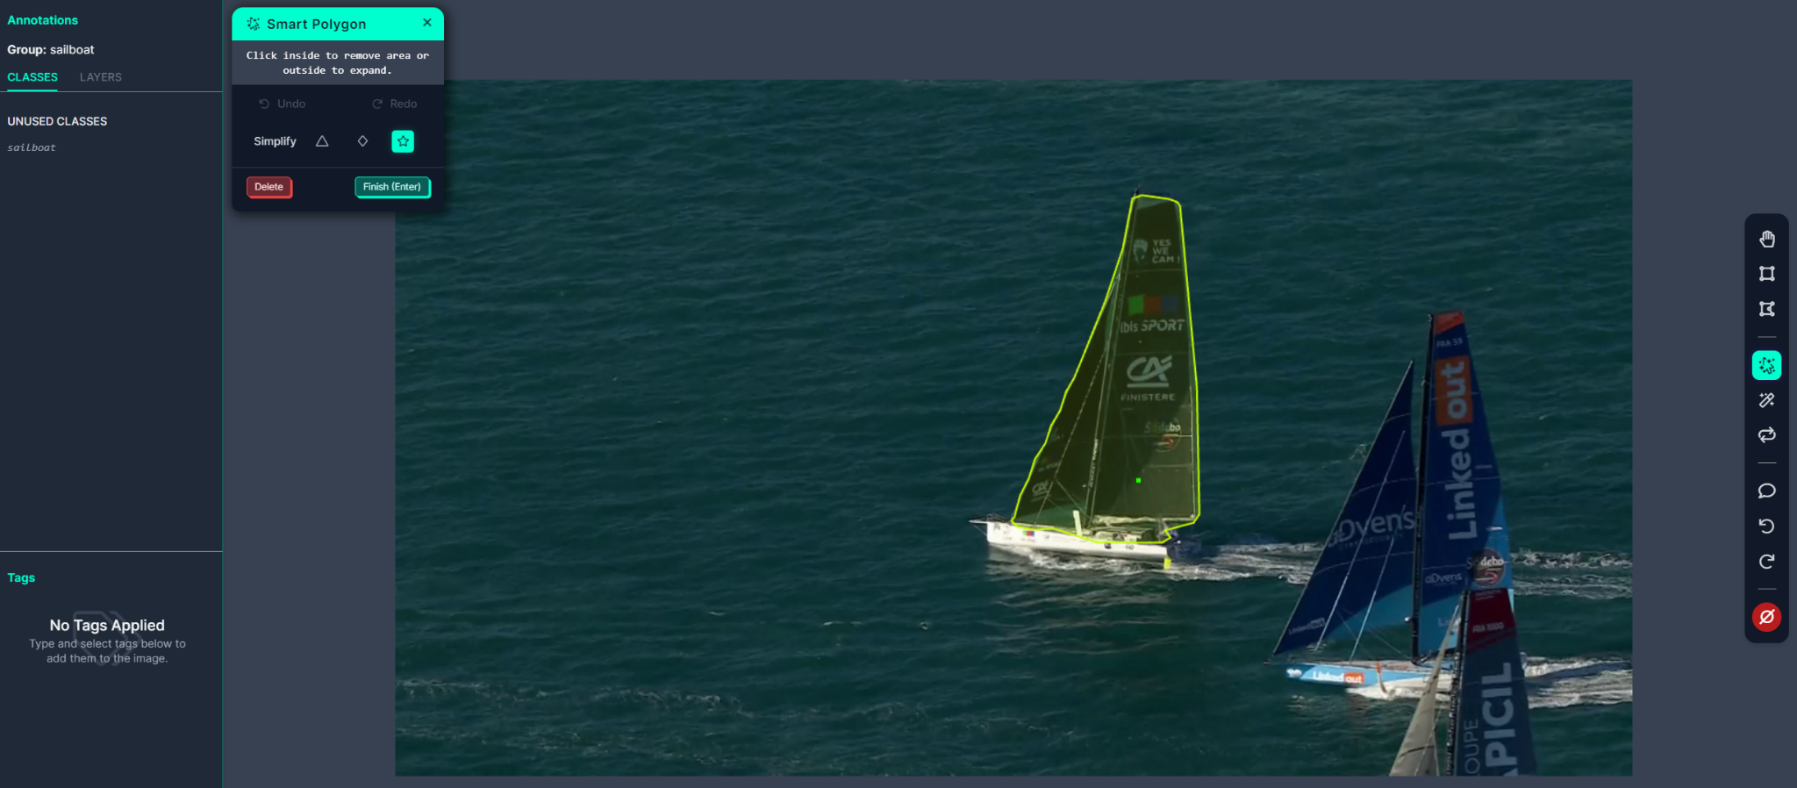

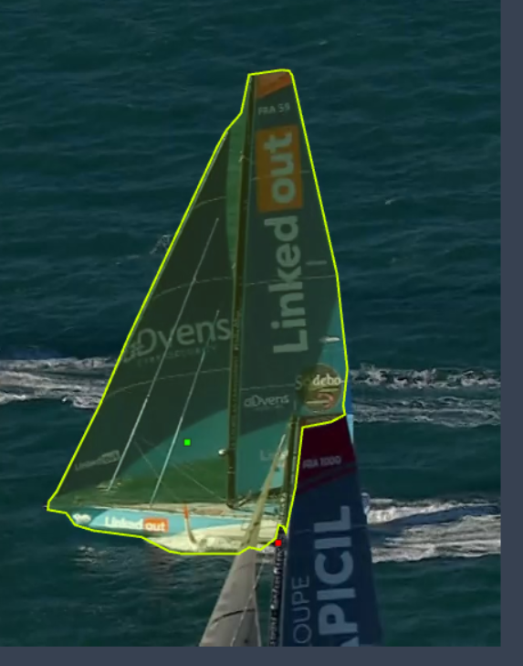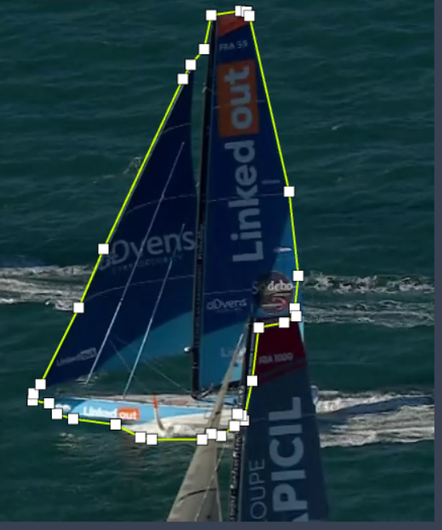

Enter + click on white points in the line to move the selection borders

Enter x2 → capture the selection as an object of the class specified in the left top corner

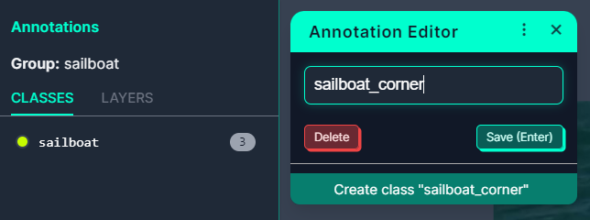

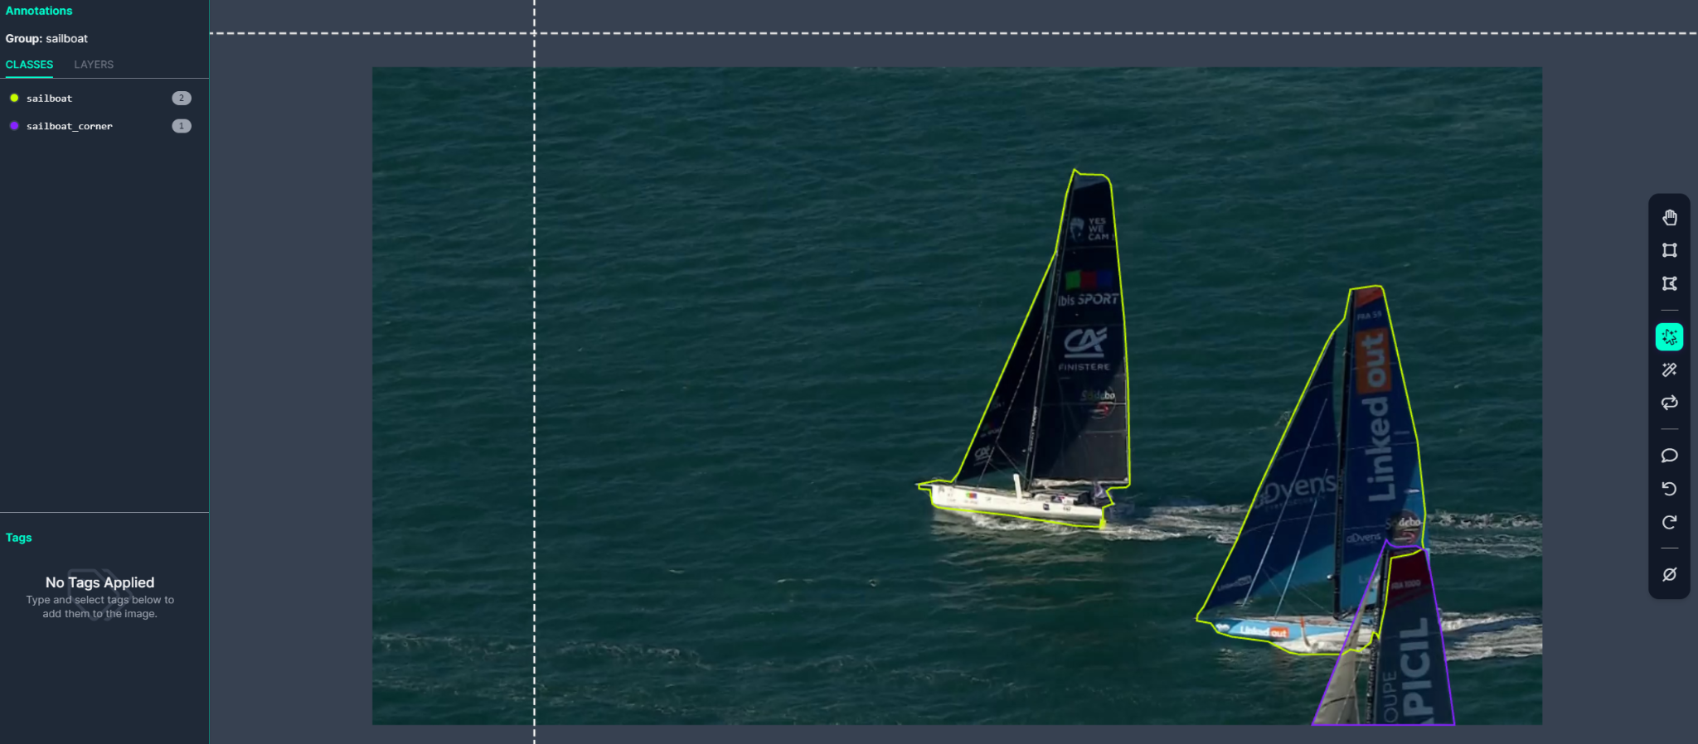

Mark Null : indicates that there is no object to detect on the image. Very useful to the learning process to have many views of what is not one of the objects to detect

To use an existing model to help labeling process, use one public model, or train a custom model on parts of your annotated dataset. If you want to use a model trained on another project or account, the model may need to be deployed and considered as public.

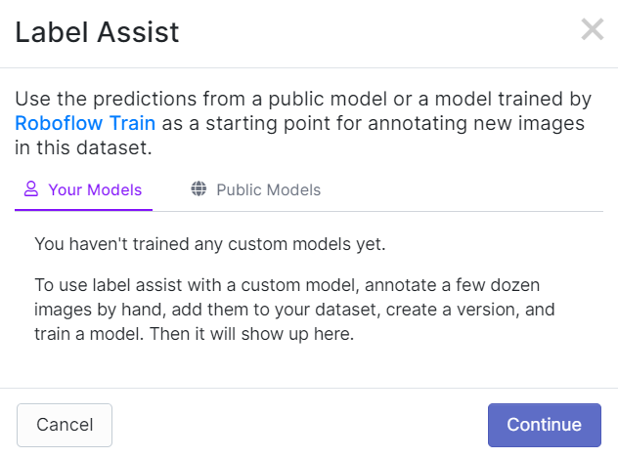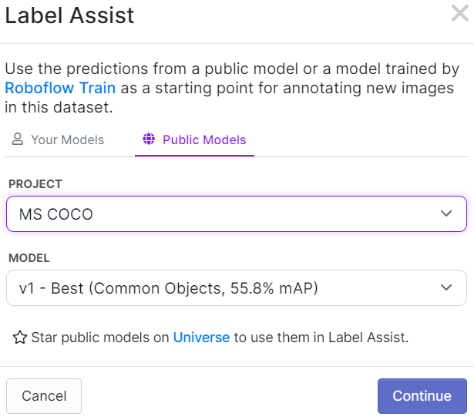

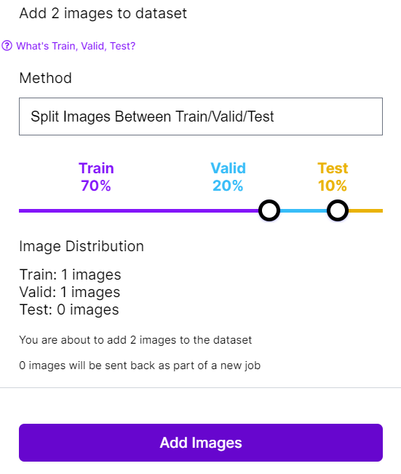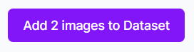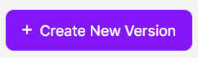

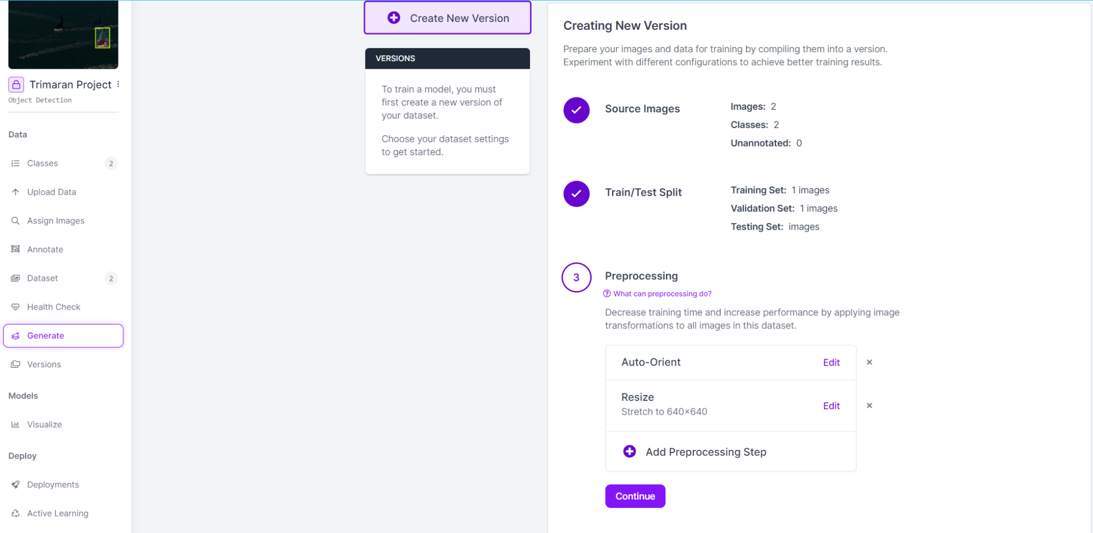

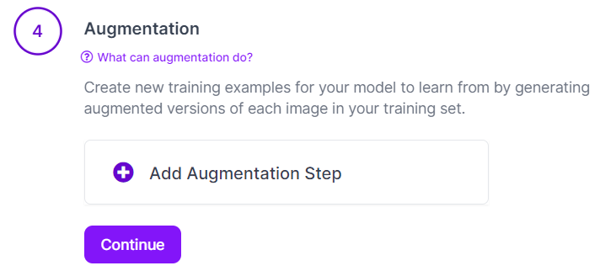

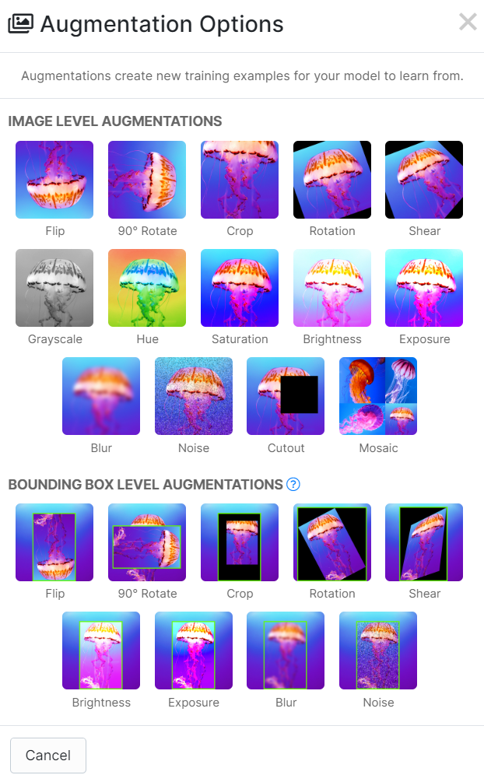

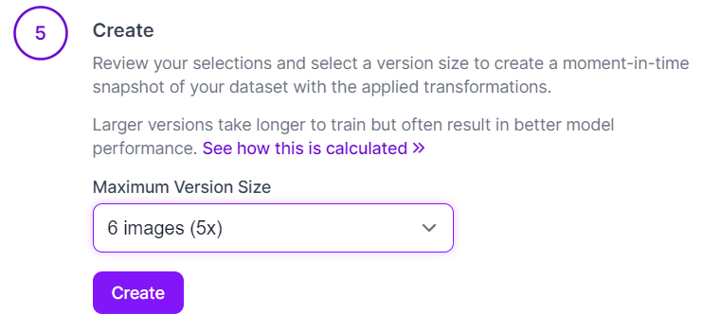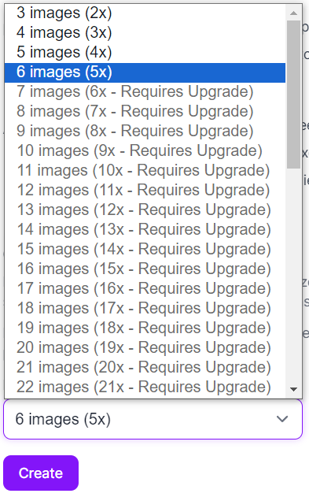

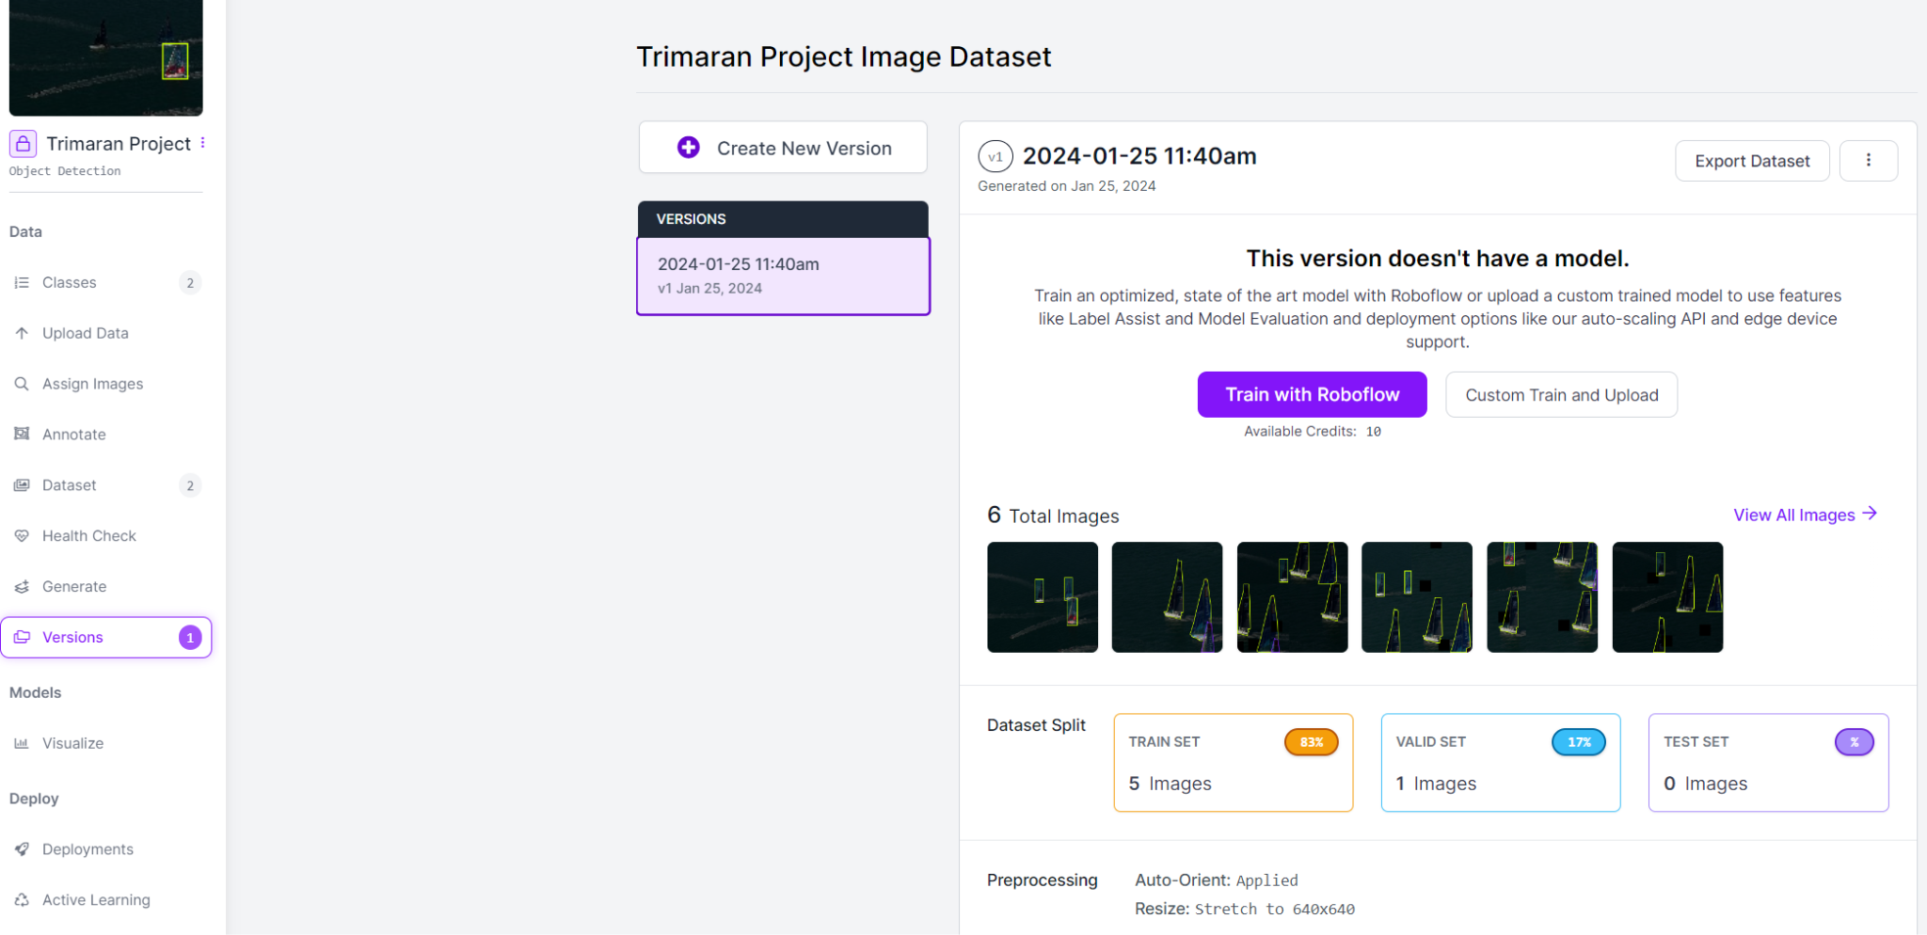

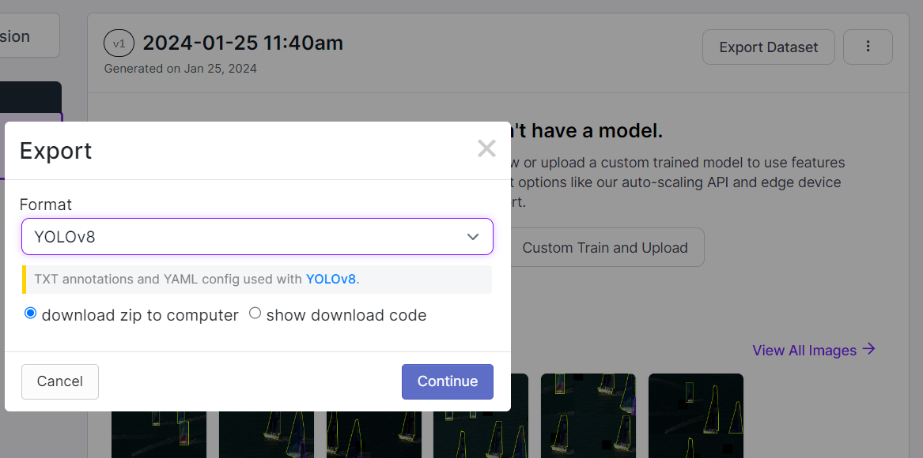

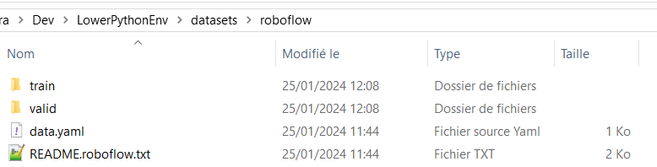

Train a model

<https://docs.ultralytics.com/fr/>

<https://pypi.org/project/ultralytics/>

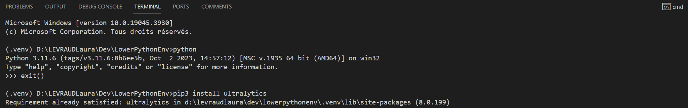

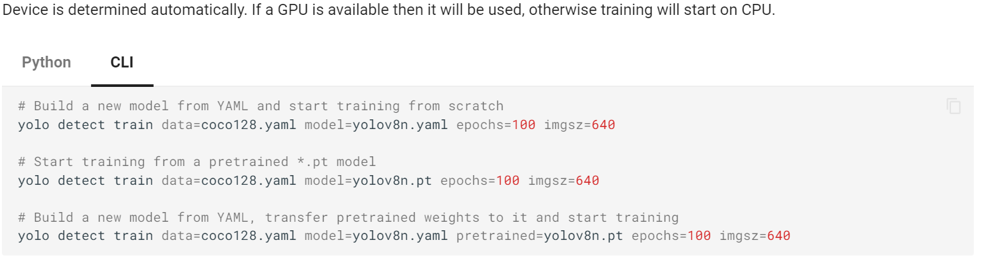

coco128.yaml → Dataset COCO used to train yolov8n (.yaml / .pt / .onnx). Common objects

to replace with the custom dataset : data.yaml

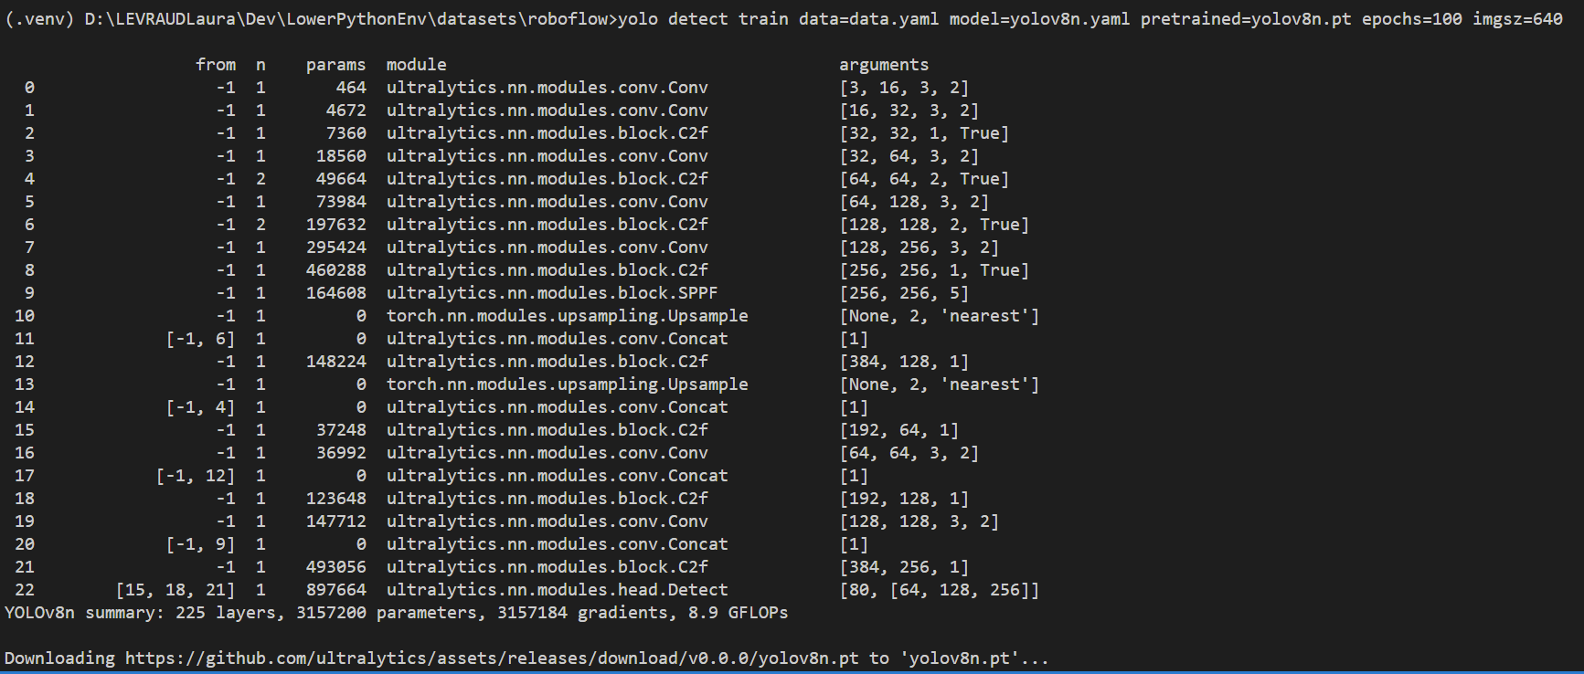



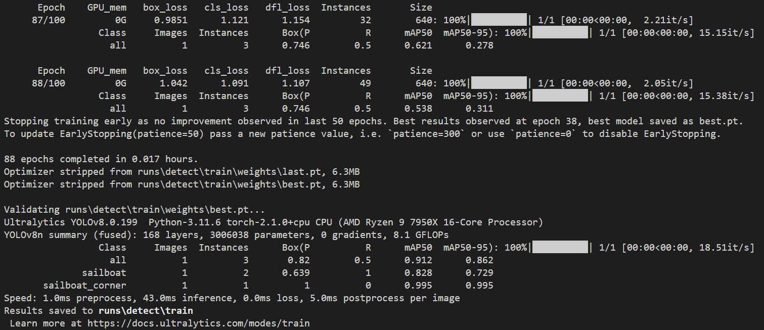

### Resume the training if interrupted (last epoch completed < total epochs ordered) :

<https://docs.ultralytics.com/fr/modes/train/>

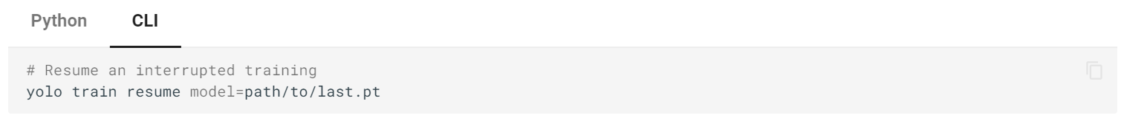

### Retrain with new dataset :

Select the last best weights and start a new training on the new dataset.



# BE CAREFUL !

Through the epochs of a model training process, the goal of the model evolution is to perform with the lowest number of errors on the dataset the model is CURRENTLY training. Imagine you have trained model 1, whose best weights are best1.pt, on dataset 1. You want to keep training this model with new data, stored in dataset 2. You use this command :

yolo detect train data=data2.yaml model=best1.pt epochs=100 imgsz=640

Then you will create a new model, initialized with best1.pt weights, that will evolve during the newt epochs as last2.pt. The goal of this training process is to save best2.pt, the weights that perform the lowest error rate on the dataset 2.

It may produce very different results from retraining best1.pt on the whole dataset formed by dataset 1 + dataset 2.

With the command :

yolo detect train data=data1+2.yaml model=best1.pt epochs=100 imgsz=640

It may take longer to train, but the model accuracy on the whole dataset (1 + 2) will be the first concern of the process. So you should retrain your model on your whole dataset, or at least on dataset based on parts of dataset 1 + whole dataset 2, from time to time. Except if you judge that the new data is more representative of the objects you want to detect now, than the old data that may become outdated.

So be careful of the choice of your dataset for the training process : it may lead to the creation of biased models.

### Test your model in python :

<https://docs.ultralytics.com/fr/modes/predict/>

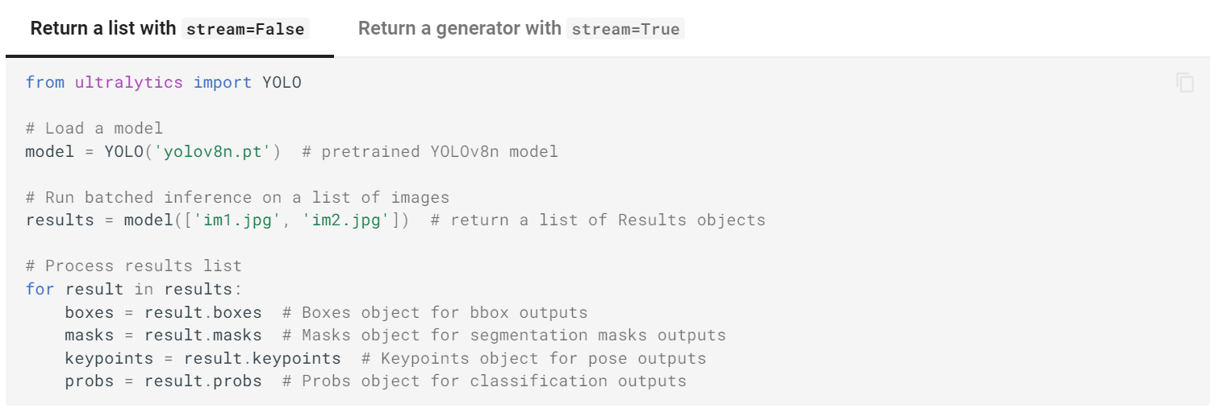

Use model.predict arguments :

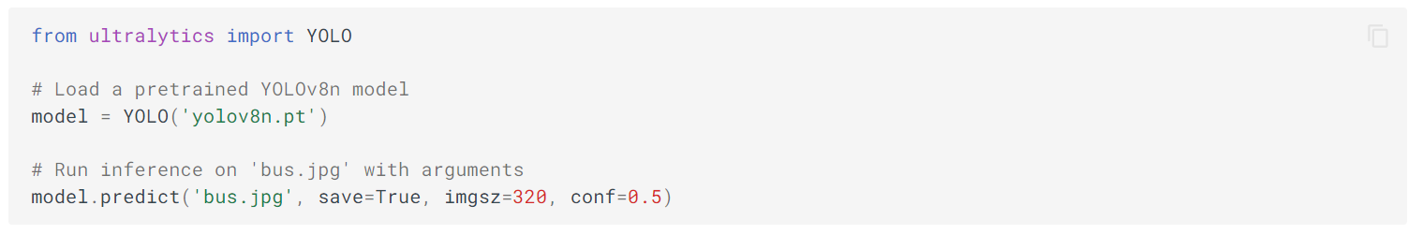

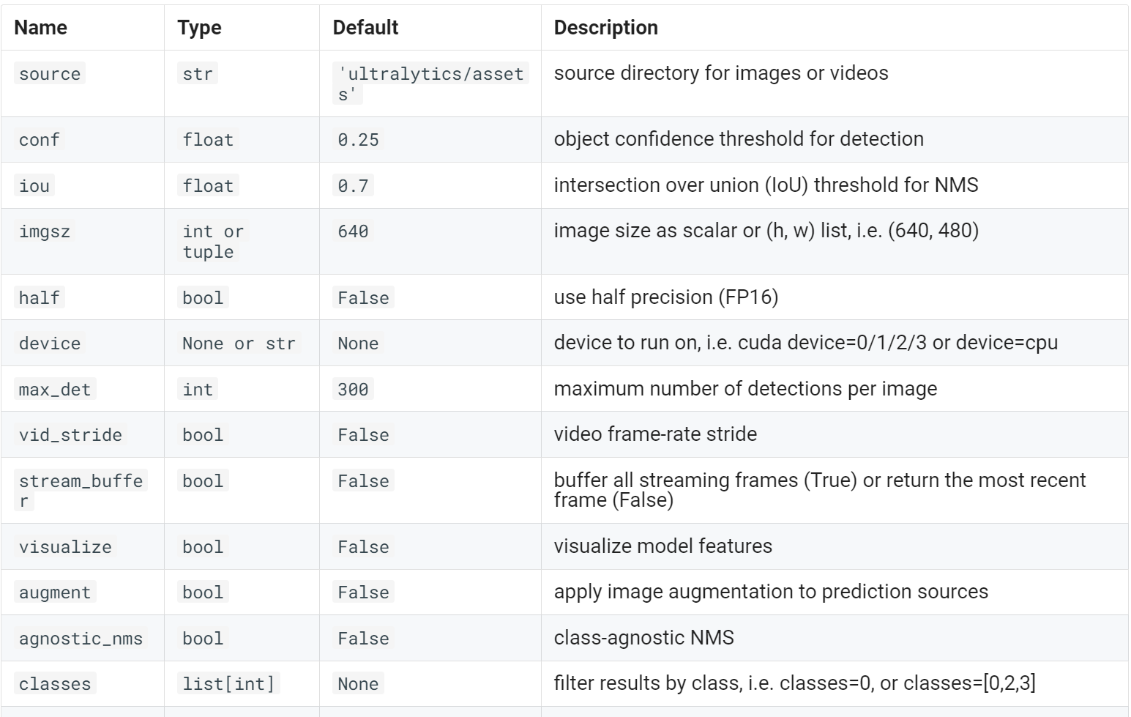

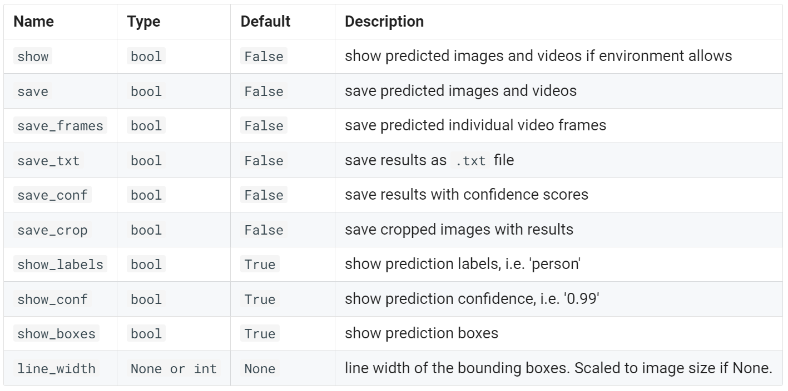

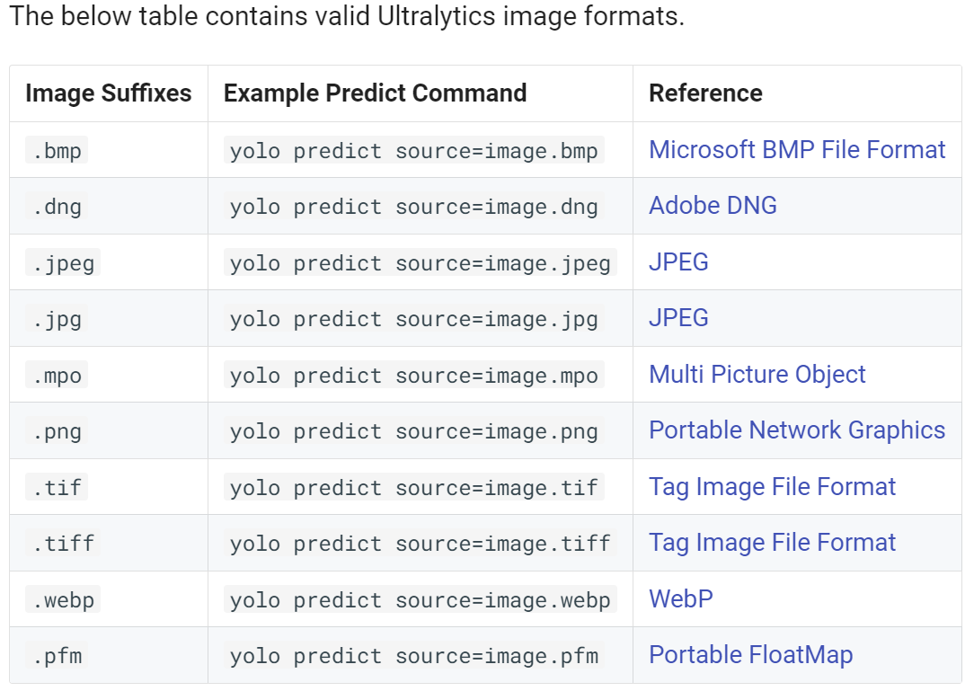

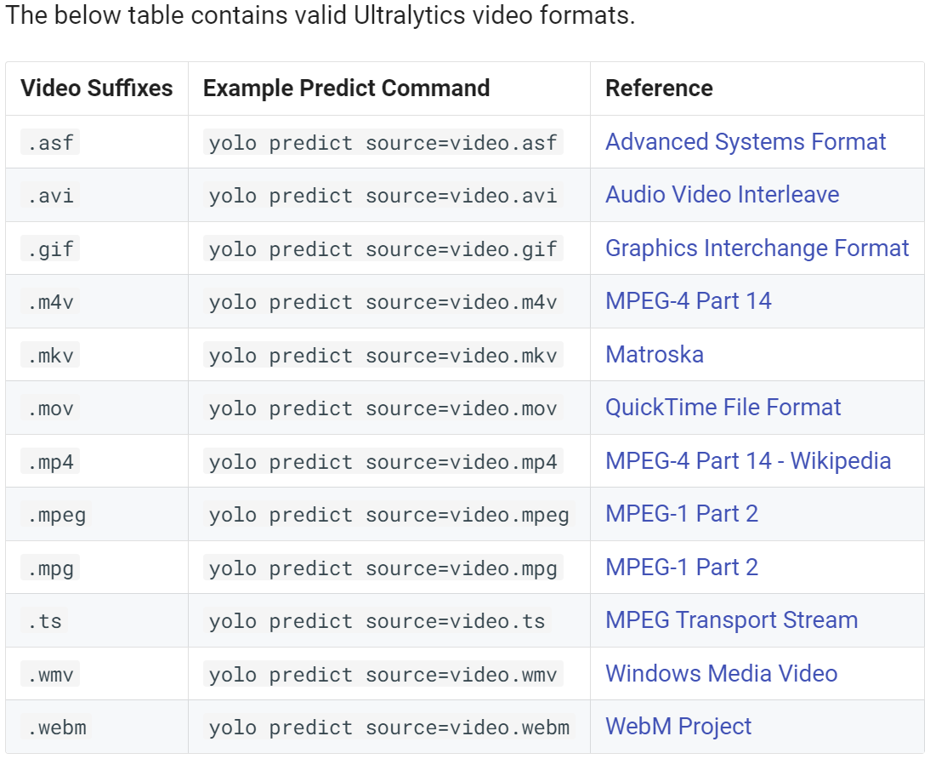

### Test your model on a video with [yolov8_detect.py](https://github.com/lauralvd01/RealTimeMOT/blob/main/YoloV8/yolov8_detect.py) :

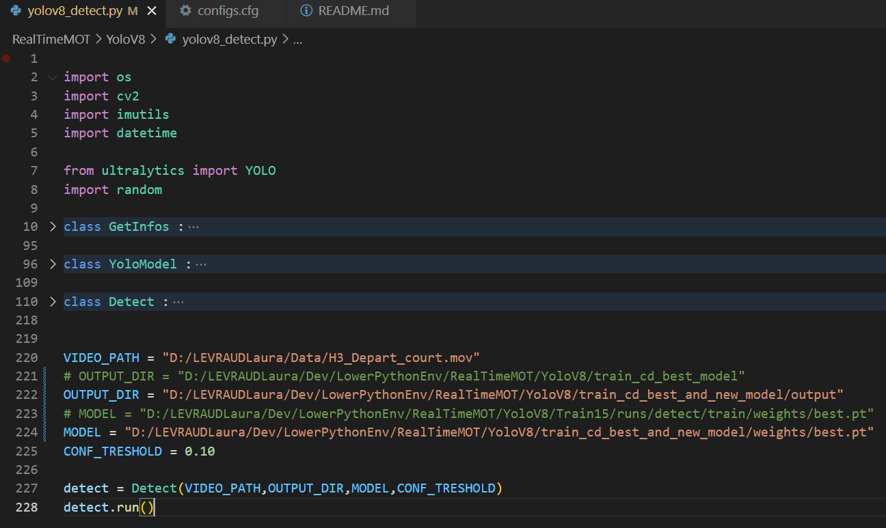

Change VIDEO_PATH, OUTPUT_DIR, MODEL and CONF_THRESHOLD parameters.

Each prediction is given by the model with a confidence score. CONF_THRESHOLD allows only the detections with higher confidence to appear in the video output.